Friends of Northern Lake Champlain
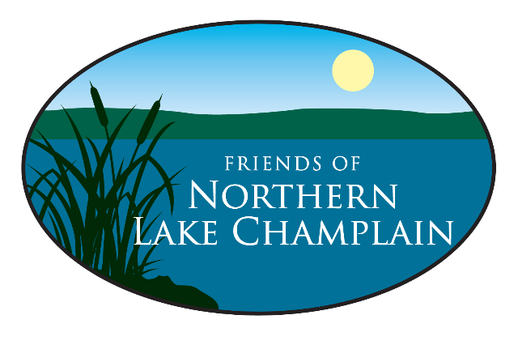
www.friendsofnorthernlakechamplain.org
Community Engagement Fellow
Location: Saint Albans, VT; hybrid work possible outside of field work
Reports to: Executive Director
Status: Full-time, exempt, 2-year fellowship
Compensation: $40K annually, with paid time off, healthcare stipend, professional development funds, mileage reimbursement for fieldwork, and access to FNLC office resources
To Apply: Please submit a resume, a cover letter describing your interest in this fellowship, and contact information for two references in a single PDF to info@friendsofnorthernlakechamplain.org, with “Fellowship Application” in the subject line.
Timeline: Applications received by January 9th will receive priority; review and interviews will begin in early January; anticipated start date is February 2026
Direct any questions to this email: info@friendsofnorthernlakechamplain.org
The Organization: The Friends of Northern Lake Champlain (FNLC) is recognized as a statewide leader that acts to clean the waters of Northern Lake Champlain and its watershed by working collaboratively with private citizens, businesses, farmers, non-profits, and government. FNLC’s focus is on catalyzing the actions and accountability needed to reduce land-use pollution and securing the essential local, state, and federal funding necessary for successful implementation.
Funding for FNLC comes from grants, donations, and events. The organization’s mission is accomplished through outreach activities, water monitoring, and the design and implementation of non-point source phosphorus reduction projects.

Fellowship Overview
This fellowship is a unique opportunity for an early-career professional with strong communication, analytical, and community engagement skills who is interested in learning how social science and stewardship practices can deepen local participation in watershed health.

Fellowship Description
The Fellow will work under the supervision of FNLC’s Executive Director, in collaboration with FNLC staff, local partners, and LCSG mentors.

Responsibilities include:
- Conducting social landscape scans and community readiness assessments through surveys, interviews, or focus groups
- Assisting with Lake Wise and stormwater technical assessments
- Support the recruitment of landowners for site visits, technical assistance, and stewardship planning
- Collaborate with staff to co-create and pilot community engagement strategies that are tailored to each subwatershed’s culture and needs
- Analyze engagement outcomes and compile lessons learned to inform a replicable model
- Produce written reports, visual materials, and a “Community Stewardship Toolkit”
- Sharing insights through blogs, presentations, community meetings, and partner events

Preferred Qualifications
- Recent degree in environmental studies, natural resources, social science, communications, sustainability, geography, or related field
- Experience or coursework in community engagement or applied research
- Strong communication and listening skills
- Ability to work independently and collaboratively
- Comfort engaging with diverse community members
- Interest in watersheds, stewardship, and rural community dynamics
- Experience with surveys, interviews, GIS, or outreach preferred but not required
- Knowledge of Lake Champlain watershed issues, native plants, or BMPs a plus

What You’ll Gain
- Hands-on experience in water quality place-based engagement
- Applied social science skills for environmental problem-solving
- Mentorship from FNLC and LCSG staff and affiliated researchers
- A growing professional network in the Lake Champlain Basin
- A strong portfolio of real-world deliverables for future career advancement

How to Apply
Please submit a resume, a cover letter describing your interest in this fellowship, and contact information for two references to info@friendsofnorthernlakechamplain.org, with “Fellowship Application” in the subject line.

