Friends of Northern Lake Champlain
Request for Proposals
May 2023

Mill River Road SE Stormwater Practices Final Design

- Introduction

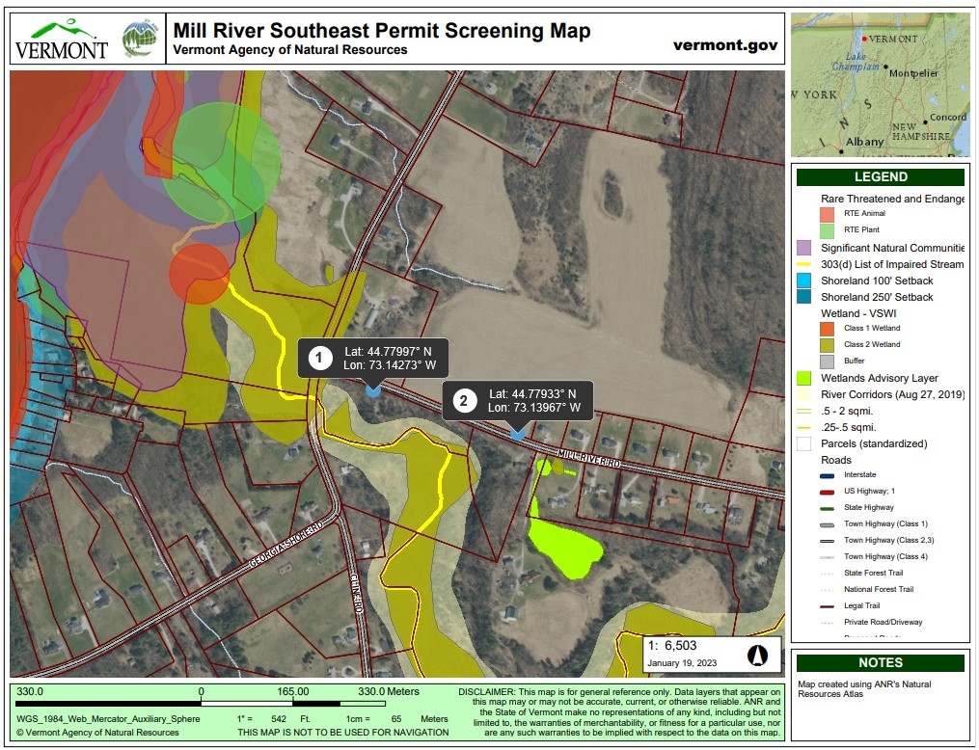
Friends of Northern Lake Champlain (FNLC) received a grant in 2020 from the Lake Champlain Basin Program to conduct a comprehensive stormwater and shoreline erosion assessment in the town of Georgia, which resulted in three 30% designs for stormwater projects that will reduce phosphorus loading into St. Albans Bay. One of the proposed projects was a combination stormwater management practices at the Southeast end of Mill River Rd (Figure 1). The section of the Mill River that is directly downstream from this proposed project is currently listed in the 2020 impaired (303d) waters due to agricultural runoff, streambank erosion, nutrient pollution, and sedimentation/siltation.
Figure 1. Mill River Southeast Permit Screening Map from ANR Atlas.
Runoff along Mill River Road was identified in this assessment to be damaging the infrastructure surrounding the road. A gully has formed (Figure 2) just uphill of Mill River and sedimentation has increased into Mill River while uncontrolled runoff has changed the landscape in this area. The construction of several homes east of the intersection in recent years has increased stormwater volume by increasing impervious cover that prevents stormwater infiltration in this area.
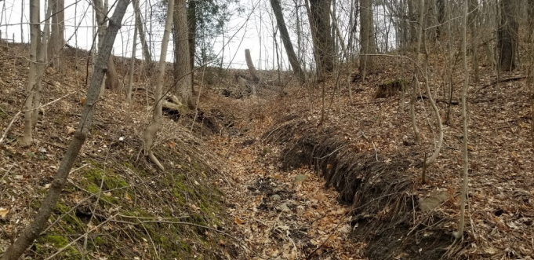
The proposed management of this area includes two BMPs that will reduce the volume of stormwater reaching the existing gully and stabilize the area to prevent future erosion. The first component of the project includes the installation of subsurface infiltration chambers within the Town right-of-way along Mill River Rd. The second component involves stabilizing the gully with stone and allowing for infiltration within the stabilized area.
Figure 2. An eroding gully has formed south of Mill River Road.
FNLC has received a grant from the North Direct Lake Basin Water Quality Council (BWQC 5) to develop a final engineering design for this project, which can be used for implementation. We hope to subcontract with an environmental consultant to develop the final design. FNLC will provide project management and outreach to municipal partners, landowners, and other stakeholders, as well as present findings to the Town of Georgia Selectboard. During a previous selectboard meeting, we received unanimous support to pursue this project.
- Scope of Work

Task # | Description | Deliverables | Timeline
Task 1 – Consultant Selection and Project Initiation | FNLC will select an environmental engineering consultant to develop the final design. We will host a project kick-off meeting with selected consultant. | Copy of RFP, Signed contract with consultant, justification for selection, and project kick-off meeting | June 2023
Task 2 – Wetland Delineation (if necessary) * | Hire consultant to perform a wetland delineation on the proposed project site to determine if a wetland permit is necessary | Updated map and/or report from delineation, determination of wetland permit | August 2023
Task 3 – Determination of Permits Required, O&M agreement, access license or easement | FNLC and the selected consultant will determine which permits are required and who will be the O&M responsible party for the implementation of the project. FNLC will work with landowners to obtain access license or easement. | Documentation of required permits, 10-year O&M draft agreement, 10-year access license or easement drafted, draft permit application materials | September2023
Task 4 – 60% Design Complete | Selected consultant will complete the 60% engineering design for the project | 60% Engineering Design | September 2023
Task 5 – 100% Design Complete | Selected consultant will complete the 100% engineering design for the project | Final Design Report (including synthesis of prior completed project deliverables, 100% design, written landowner commitment to implement project, opinion of probable costs, and basic bid document for implementation) | December 2023
* The initial permit screening process demonstrated that a wetland delineation may be required to determine whether a wetland permit is necessary. Through a desktop review, Julie Follensbee, regional wetland ecologist, suggested that a 3-9026 General Permit may be necessary.

- Content of Proposals

Responses to this request for proposals (RFP) should consist of the following:
- A statement identifying individuals who participated in the preparation of the proposal as well as a single point of contact.
- A list of individuals that will be committed to this project and their professional qualifications. The names and qualifications of any sub-consultants shall be included in this list.
- A scope of work and project budget. The budget should provide hourly rate information. The effort will be reimbursed on a time and materials basis.

- Project Budget

Friends of Northern Lake Champlain received a grant from the North Direct Lake Basin Water Quality Council with a budget of $13,000 (including $1,000 for wetland delineation, if necessary) allocated to consultant fees to develop the 60% design, 100% final design, documentation of required permits, O&M agreement, final design report, opinion of probable cost for implementation, and basic bid document for implementation.

- Other Requirements

FNLC requires its contractors to maintain workers compensation and liability insurance. Contractors must submit proof of adequate insurance coverage on an annual basis for the duration of the project. The Contractor shall, at its sole expense, obtain and maintain in force, and shall require any subcontractor or assignee to obtain and maintain in force, both for the benefit of FNLC, the following kinds and amounts of insurance:

- Workers’ Compensation Insurance. The policy shall cover the obligations of the Contractor in accordance with the Workers’ Compensations Law and Disability Benefits Law covering all operations under the Contract, whether performed by it, or by its subcontractor.
- Liability and Property Damage Insurance. Unless otherwise specified, each policy shall have limits not less than: $2,000,000 combined (Bodily Injury & Property Damage); $3,000,000 aggregate, single limit per occurrence.

- Submissions

Consultants wishing to be considered for this project should submit a complete proposal including a detailed project budget via email only to:

Kent Henderson
Board Chair
Friends of Northern Lake Champlain
khenderson@friendsofnorthernlakechamplain.org

Please use “Mill River SE Final Design” in the subject line. We must receive all proposals no later than 5 PM on June 9th, 2023. Prospective consultants may request a copy of the 30% design for this project in order to develop their proposal. Please email aspasyk@friendsofnorthernlakechamplain.org to request the 30% design.

- Contract Time Period

Contractors may begin work as soon as the selection process is complete. The final design for this project is expected to be completed by December 2023.

