Friends of Northern Lake Champlain
Request for Proposals
May 2023

Swanton Beach Stormwater BMPs - Final Design

- Introduction

Friends of Northern Lake Champlain (FNLC) received a grant in 2021 from the Lake Champlain Basin Program to conduct a shoreline assessment of the towns of Swanton and Highgate. This assessment resulted in two 30% engineering designs for stormwater management practices, one in each town. The proposed Swanton project was designed as two distict practices near the Swanton Beach. This concept includes an under-drained bioretention system to the south of the beach parking area and a roadside sand filter near the Maquam Shore Road/Lasnier Road intersection to treat runoff prior to its discharge via a stream that flows along the northern edge of the Swanton Beach property. This site was deemed important due to its location on municipal land, its education and outreach potential, and its proximity to Lake Champlain. The bioretention practices will also include educational signage when implemented, due to its highly visible and public location.
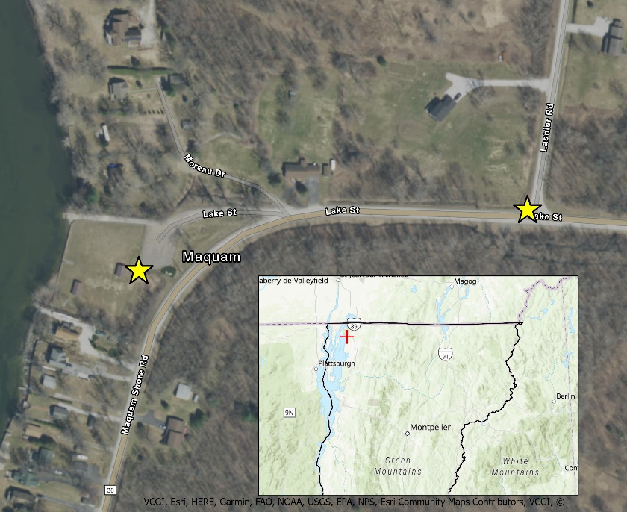
FNLC has received another grant from the Lake Champlain Basin Program to develop a final design for this proposed project and implement the project based on the design. We hope to sub-contract with an environmental consultant to develop the final 100% engineering design. FNLC staff will provide project management and outreach to municipal partners, adjoining landowners, and other stakeholders, as well as present findings to the Town of Swanton Selectboard and the Village Trustees. During a previous selectboard meeting, we received unanimous support to pursue this project.
Figure 1. Location of the proposed stormwater BMPs.
- Scope of Work

Task # | Task Title | Objective | Deliverable(s) | Timeline
1 | Consultant Selection and Project Initiation | FNLC will select environmental engineering consultant to develop the final design | Copy of RFP, signed contract with consultant | June 2023
2 | Determination of Permits Required and O&M Responsible Party | FNLC and selected consultant will determine which permits are required and who will be the O&M responsible party for the implementation of the project | Documentation of required permits for project implementation, indicating potential challenges/conflicts for obtaining permit, and documentation of O&M responsible party once project is implemented | August 2023
3 | 60% Design Complete | Selected consultant will complete the 60% engineering design for the project | 60% Engineering Design | September 2023
4 | Final 100% Design Complete | Selected consultant will complete the final engineering design for the project | Final Design Report (including synthesis of prior completed project deliverables, 100% design, written landowner commitment to implement project, opinion of probable costs, and basic bid document for implementation) | December 2023
5 | Select Contractor | FNLC will select a contractor to construct the two BMPs according to the final engineering design | Signed contract with contractor | February 2024
6 | O&M Agreements and Permit Documentation | Selected consultant will obtain all necessary permits for project implementation and develop an O&M agreement. FNLC obtain signatures for O&M agreement. | Copy of signed permits and O&M agreement | April 2024
7 | Project Construction | Selected consultant and FNLC will provide oversight of project construction and design guidance | Photos of project location before and after construction, post-construction report | July 2024
8 | Educational Signage | FNLC will design and install an educational placard next to the bioretention BMP | Copy of the design and photos of the installed placard | August 2024
9 | Project Final Report | FNLC will complete all final reporting to close out the grant | Cumulative LCBP final project report, project metrics report, and quarterly reports | September 2024

- Content of Proposals

Responses to this request for proposals (RFP) should consist of the following:
- A statement identifying individuals who participated in the preparation of the proposal as well as a single point of contact.
- A list of individuals that will be committed to this project and their professional qualifications. The names and qualifications of any sub-consultants shall be included in this list.
- A scope of work and project budget. The budget should provide hourly rate information. The effort will be reimbursed on a time and materials basis.

- Project Budget

Friends of Northern Lake Champlain received a grant from the LCBP with a budget of $12,000 allocated to consultant fees to develop the 60% design, 100% final design, documentation of required permits, O&M agreement, final design report, opinion of probable cost for implementation, basic bid document for implementation, oversight of project construction, and post-construction report.

- Other Requirements

FNLC requires its contractors to maintain workers compensation and liability insurance. Contractors must submit proof of adequate insurance coverage on an annual basis for the duration of the project. The Contractor shall, at its sole expense, obtain and maintain in force, and shall require any subcontractor or assignee to obtain and maintain in force, both for the benefit of FNLC, the following kinds and amounts of insurance:

- Workers’ Compensation Insurance. The policy shall cover the obligations of the Contractor in accordance with the Workers’ Compensations Law and Disability Benefits Law covering all operations under the Contract, whether performed by it, or by its subcontractor.
- Liability and Property Damage Insurance. Unless otherwise specified, each policy shall have limits not less than: $2,000,000 combined (Bodily Injury & Property Damage); $3,000,000 aggregate, single limit per occurrence.

- Submissions

Consultants wishing to be considered for this project should submit a complete proposal including a detailed project budget via email only to:

Kent Henderson
Board Chair
Friends of Northern Lake Champlain
khenderson@friendsofnorthernlakechamplain.org

Please use “Swanton Town Beach Final Design” in the subject line. We must receive all proposals no later than 5 PM on June 9th, 2023. Prospective consultants may request a copy of the 30% design for this project in order to develop their proposal.

Please email aspasyk@friendsofnorthernlakechamplain.org to request the 30% design.

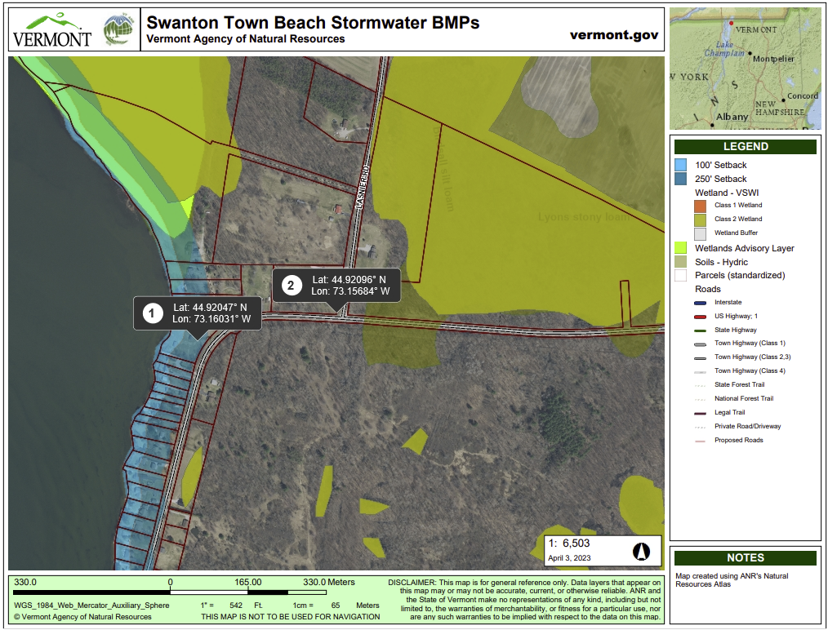
Figure 2. ANR permit screening map of the location locations near the Swanton Beach where this proposed project is located.

